**CSP Pswd reset process**

[Sales Service Delivery Quotation](http://ebiz.sbc.com/mots/detail.cfm?appl_id=26705)

1. Receive email request for pswd reset from Kimberly McFadden and copy userid.

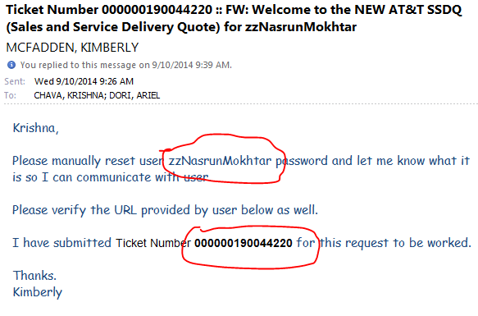

1. login [https://www.e-access.att.*com*/usersvcs/delgadmin/](https://www.e-access.att.com/usersvcs/delgadmin/) paste userid and click Search.

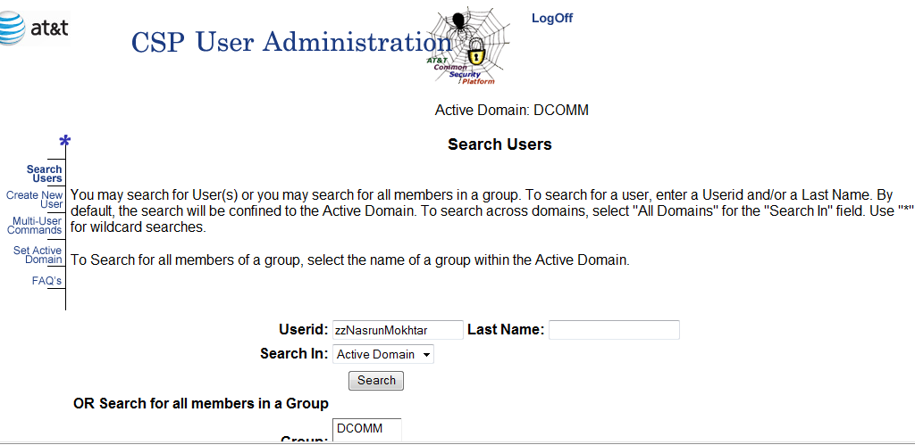

* 1. Superuser login (required) – follow steps in email below:

1. Initiate Password Reset

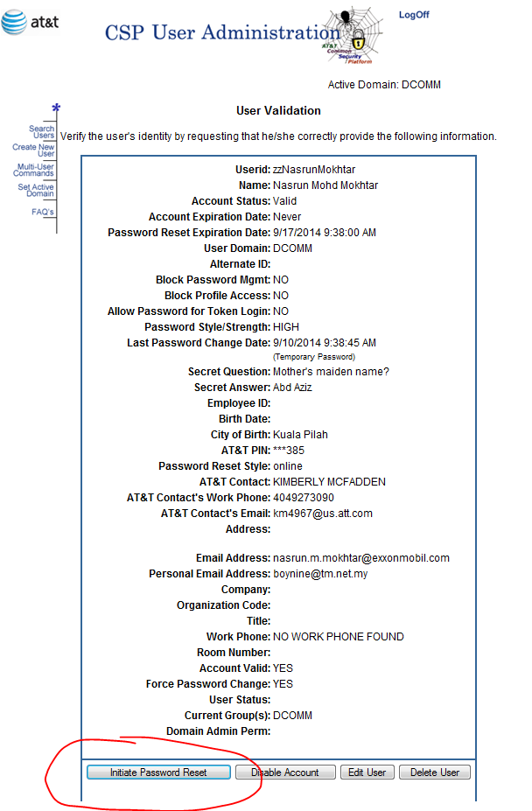

1. Copy Pswd Notification screen shot and email to Kimberly along with new pswd.

* Include the typed pswd as in: ‘The pswd for this user has been reset to:  **23fred99’  
  -** this is so Kimberly can copy paste to user, avoiding typing errors.

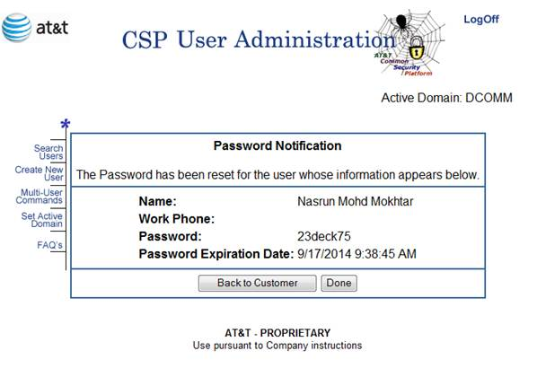

1. Log off CSP

**CSP Create External User process**

1. Receive email request for pswd reset from Kimberly McFadden and copy userid.
2. login <https://www.e-access.att.com/usersvcs/delgadmin/> paste userid; All Domains; and click Search
   1. verify that userid is not found
3. click Create New User
   1. populate: Userid; First Name; Last Name; Email Address (from kim email or ticket); AT&T Contact ATTUID: km4967; Add To Group(s): DCOMM; and Check box for user to receive email notification.
   2. Click Save  
      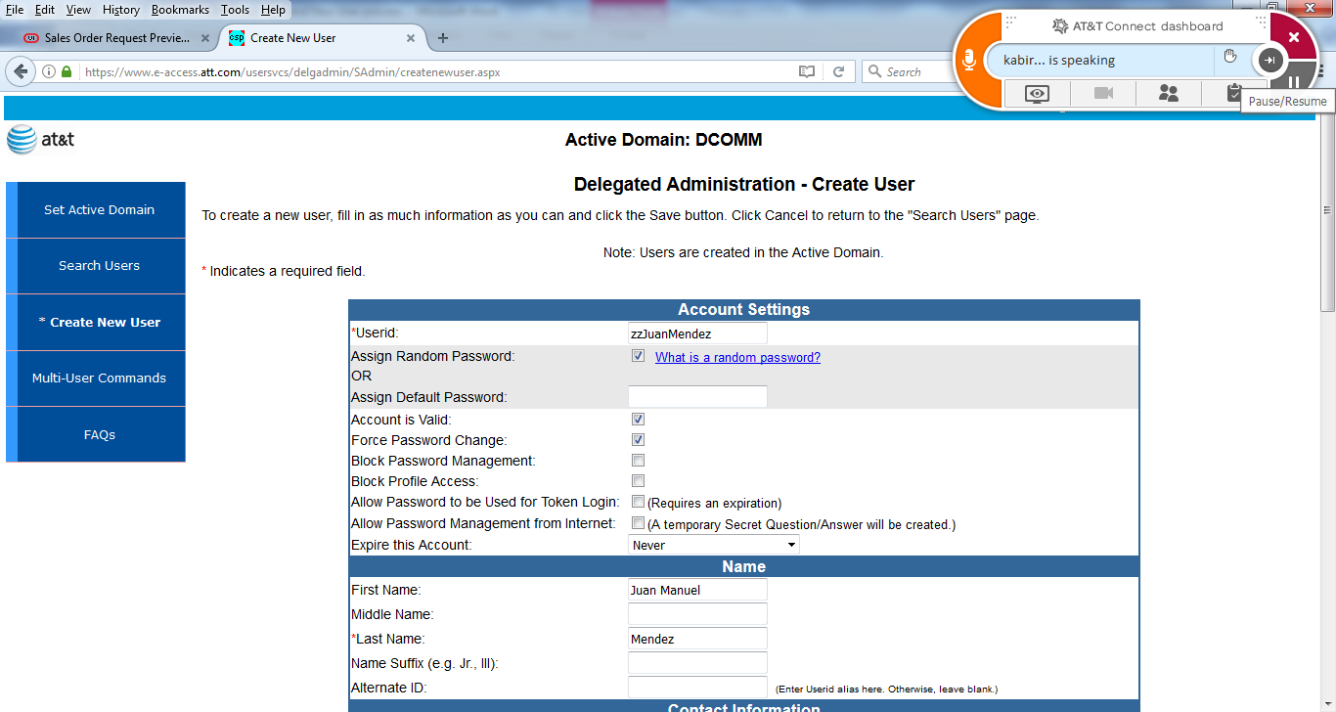
   3. 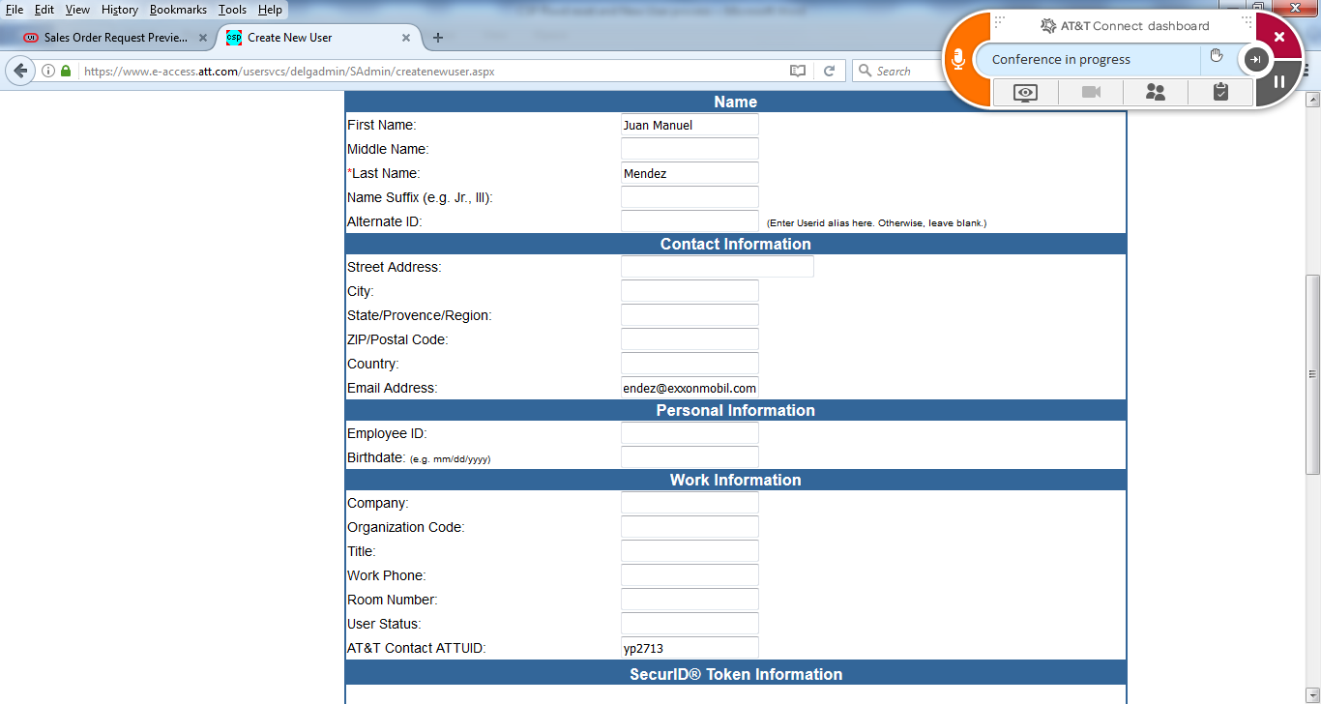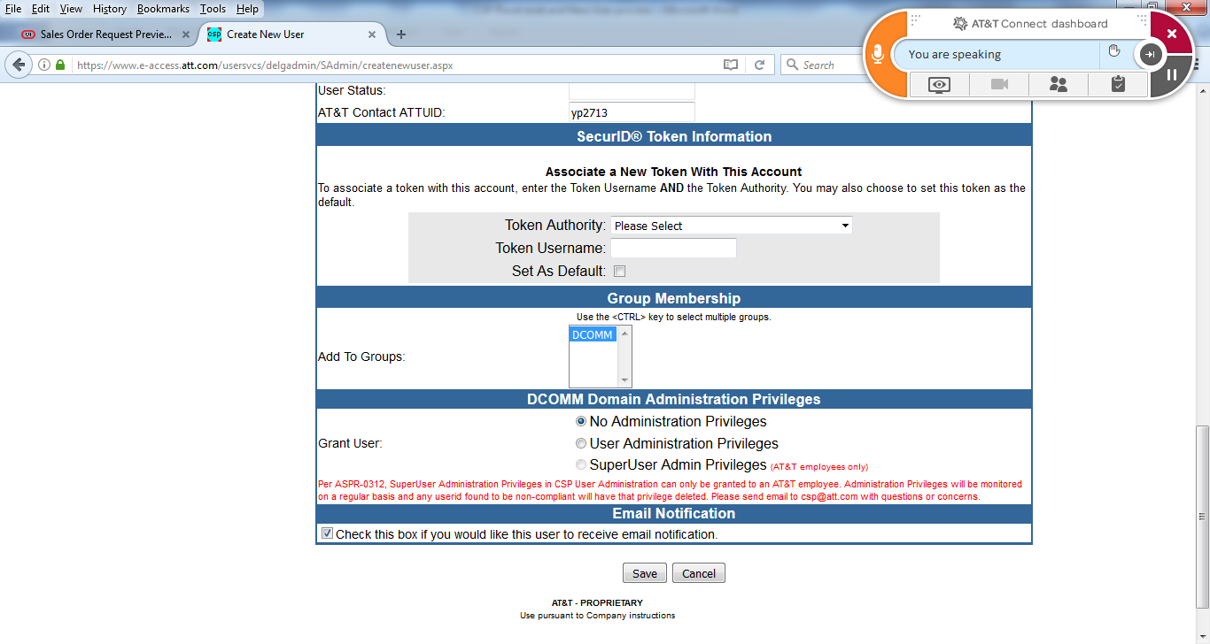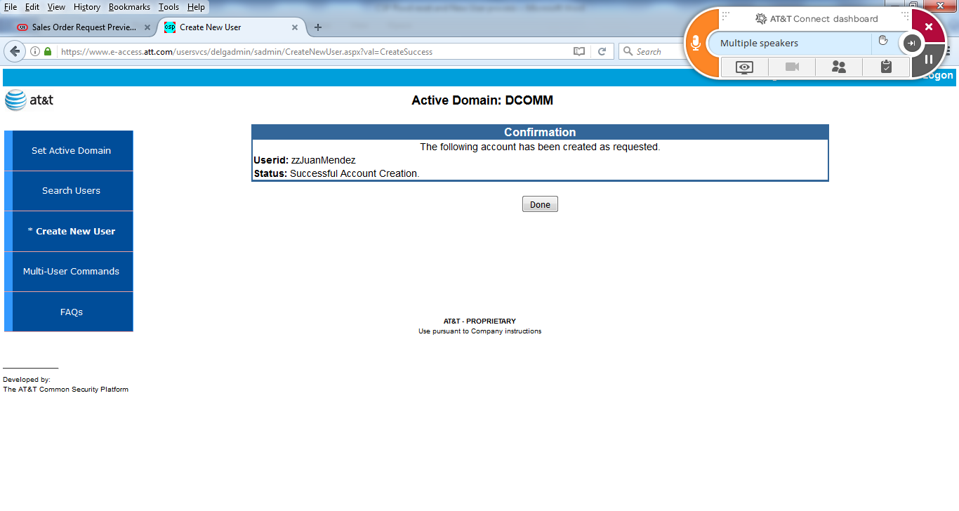
4. Copy confirmation msg and email Kimberly.



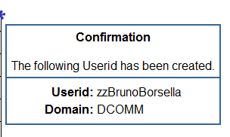

1. Log off CSP